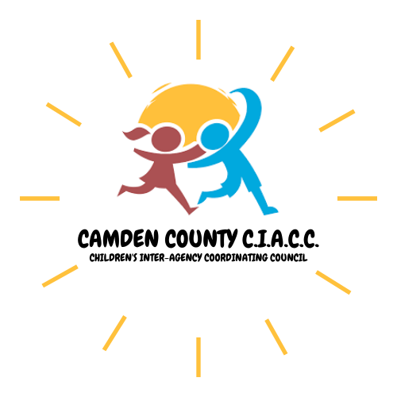

Camden County Children’s Inter-Agency Coordinating Council
General Meeting

Convene Open Public Meeting Statement:
“This meeting is being held in accordance with the provisions of the Open Public Meetings Act, N.J.S.A. 10:4-6 – 10:4-21.”

Mission Statement: The Camden County Children’s Inter-Agency Coordinating Council (CIACC) serves as the county mechanism to advise the Department of Children and Families (DCF) on the development and maintenance of a responsive, accessible, and integrated system of care for children, youth, and young adults with emotional, mental, and behavioral challenges, intellectual and developmental disabilities, and substance use service needs.

June 25, 2024
Agenda

- Welcome/Introductions/Mission Statement

- Review of Minutes

- Presentations – N/A

- System Coordination Reports:
  - Care Management Organization
  - Family Support Organization
  - Mobile Response and Stabilization Services
  - Adolescent Addiction
  - Division of Child Protection & Permanency
  - Juvenile Justice Commission

- Conveners Report

- Subcommittee Reports:
  - Educational Partnership Program
  - Intellectual/Developmental Disabilities Subcommittee
  - Family Voice Subcommittee

- New Business/ Round Table/Announcements
  - Open Discussion

NEXT MEETING: July 2, 2024 10:30 a.m.

